Tutorial in Escher

Introduction:
Escher is a web-base tool for building ,viewing , and sharing visualizations of biological pathways .
Utilizing this tool and a Genome Scale Metabolic Model (GSMM) from Cobrapy it is feasible to visualize the pathway of the Model.(Ebrahim, Lerman, Palsson, & Hyduke, 2013) (King et al., 2015)⁠⁠⁠

From SBML to JSON file:

Cobra py supports for reading and writing SBML,JSON,YAML,MAT , and pickle formats. The most common one is the SBML file. On the other hand Escher can function only with JSON files. So the first step in order to start building the virtualization of the GSMM is to create a JSON file. This can be done by saving the model as JSON file as it is described in cobra py documentation(Hyduke & Ebrahim, 2017)⁠

Building the visualization of the model:

Having the the model in JSON format head to https://escher.github.io/ and click on ‘Load map’ as in illustration 1.
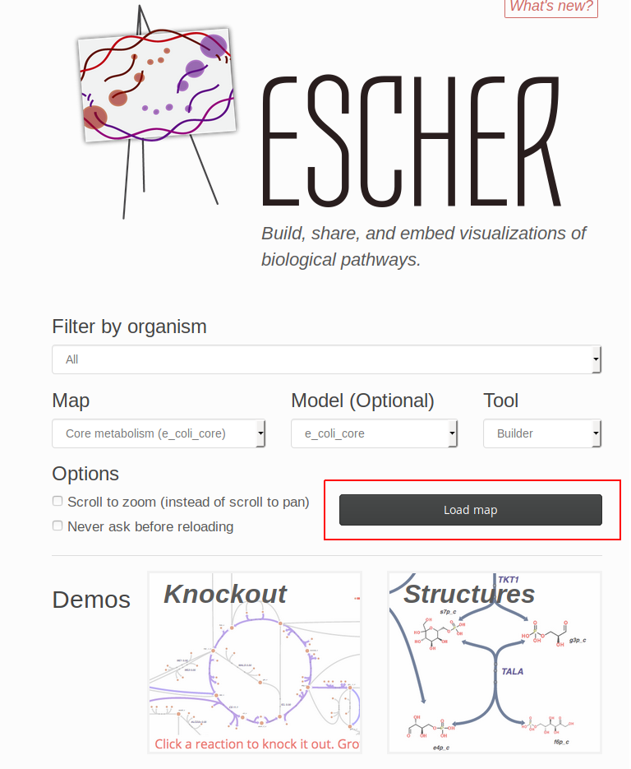Illustration 1: Escher main page

A new window will pup-up by selecting in the upper of the page ‘Map’ press ‘Clear map’ as in illustration 2.

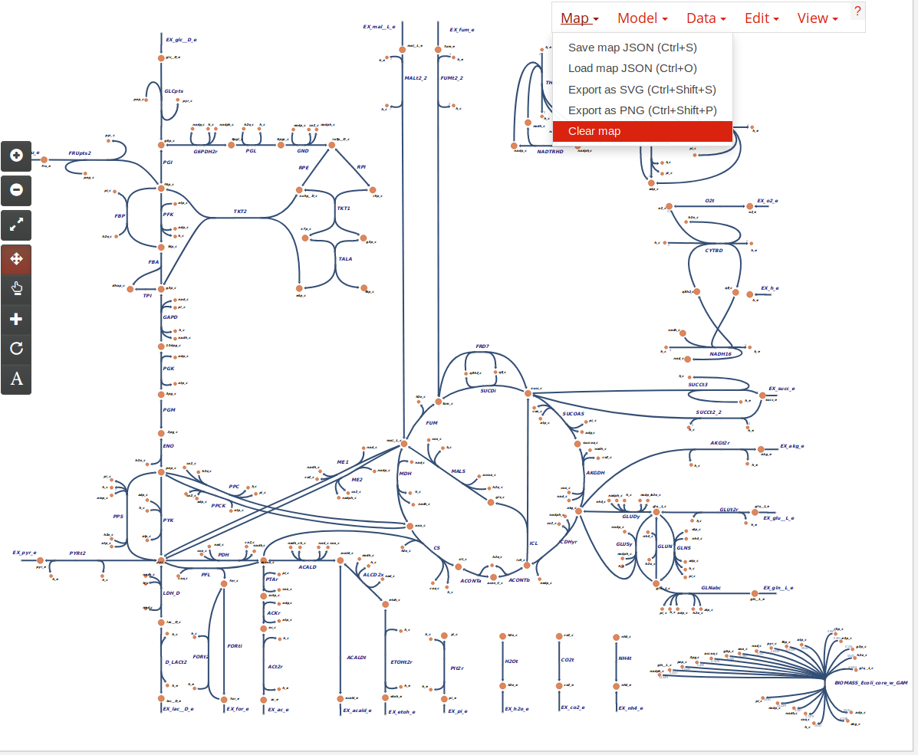Illustration 2: Clearing the pre-existing map

After clearing the per-existing map click again in the top of the page to ‘Model’ and press ‘Load COBRA model JSON’
Illustration 3: Loading the model
Again click on the ‘Model’ and select ‘ Update names and gene reaction rules using model’
Illustration 4: Use the model to load the reaction names and genes
Now the reactions from the GSMM can be added by pressing and the top of the screen ‘Edit’ and then ‘ Add reaction mode’ or in the left side the page the button for adding reactions.

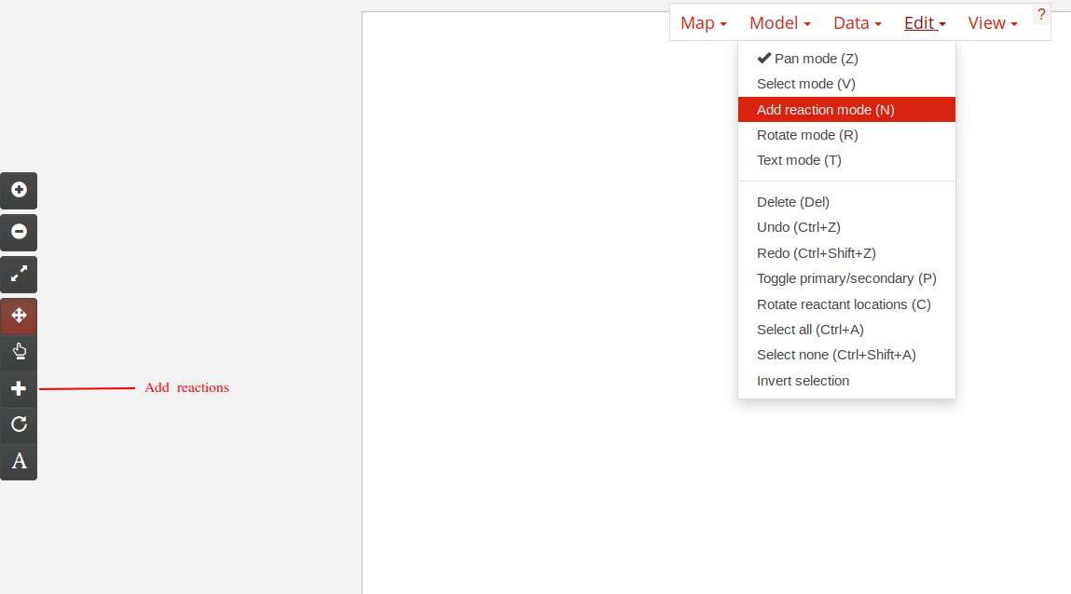Illustration 5: Add reactions
After this a list of all reactions that are in the GSMM will appear after you click in the white screen . By selecting the reactions that you need they will automatically appear in the screen as a visualization . Escher can identify the reversibility of a reaction also the reactants and the products so it helps the user to select from a list of reactions that can occur after a certain reaction.
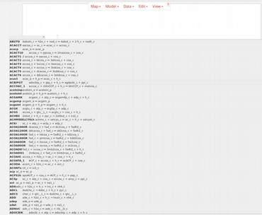Illustration 6: List of reactions and visualization

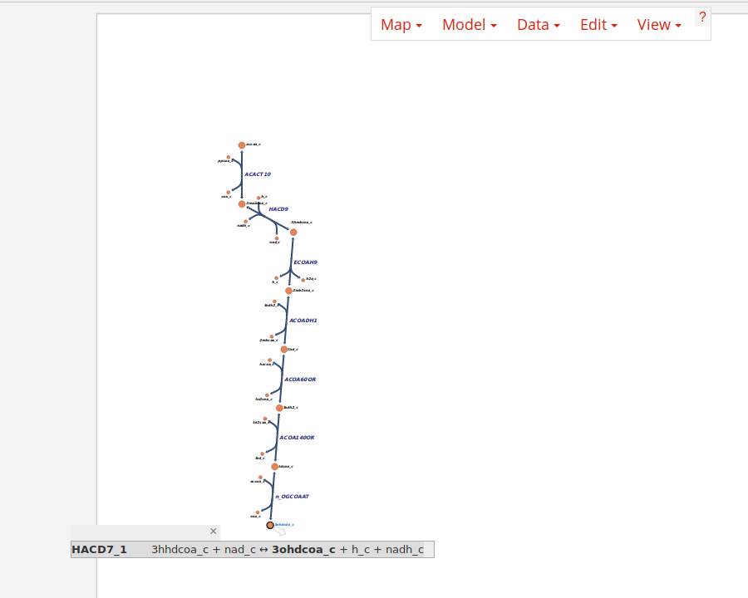

Also Escher allows you to load more information about the genes , reactions and metabolites of the model by selecting ‘Data’ . Note the files much again be in JSON format

Further more in the ‘Edit’ you can find the ‘Pan mode’ that allows the user to navigate around the model . The ‘Select mode’ that helps with picking and moving one or more reactions . All this functions can be found also in the left side of the screen.

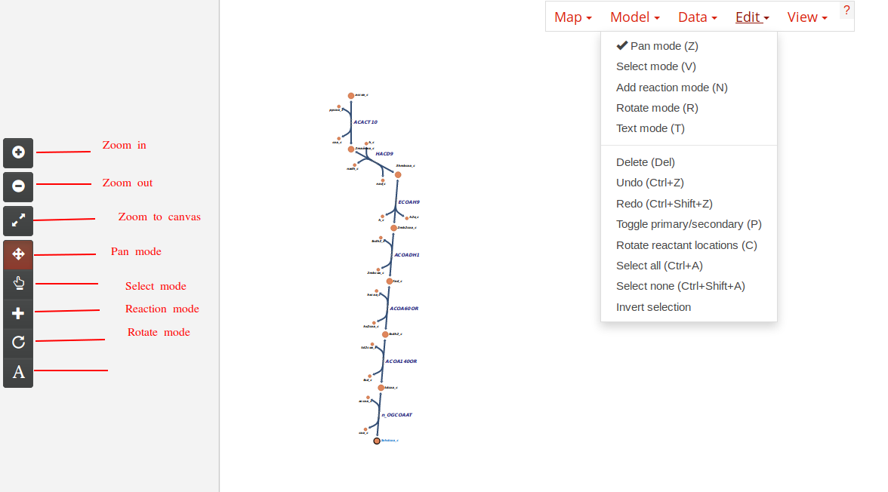Illustration 7: Functions for navigation and move reactions in the model
In order to save the model click on ‘Map’ on the top of the screen and select ‘Save model JSON ’

Knockout and Structures demos:

Having the model been built return to the main page of Escher and press on Knockout. Clear the already existing map and load the one that has been built . In this demo version it is possible to do Knockouts and see how the model response.

Also Escher allows for a more detailed structure view of the built model.

References :

Ebrahim, A., Lerman, J. A., Palsson, B. O., & Hyduke, D. R. (2013). COBRApy: COnstraints-Based Reconstruction and Analysis for Python. BMC Systems Biology, 7. https://doi.org/10.1186/1752-0509-7-74
Hyduke, D. R., & Ebrahim, A. (2017). cobra Documentation.
King, Z. A., Dräger, A., Ebrahim, A., Sonnenschein, N., Lewis, N. E., & Palsson, B. O. (2015). Escher: A Web Application for Building, Sharing, and Embedding Data-Rich Visualizations of Biological Pathways. PLoS Computational Biology, 11(8), 1–13. https://doi.org/10.1371/journal.pcbi.1004321

